C.V. RAMAN GLOBAL UNIVERSITY

BHUBANESWAR, ODISHA-752054

DEPARTMENT OF COMPUTER SCIENCE & ENGINEERING



DBE CASE STUDY

REPORT

ON

“STADIUM SEAT

MANAGEMENT SYSTEM”

|  |  |
| --- | --- |
| NAME | MRINAL DAS |
| REGD. NO. | 2201030018 |
| SEMESTER | 4TH |
| BRANCH | CSIT |

CONTENT

1. Introduction
2. A feasibility study and Requirement Analysis
3. Table Description with all constraints
4. Design ER Diagram
5. Relational Database Schema
6. Normalized table (Up to 2NF)
7. Conclusion

References

Declaration

I Mrinal Das, hereby declare that the project work entitled " Stadium Seat Booking Management System" submitted to the CV Raman Global University, is a record of an original work done by me under the guidance of Dr. Prasant kumar Das and Ms. Jayanti Rout and this project work is submitted in the partial fulfilment of the requirements for the award of the degree of Bachelors of the Technology in the computer Science & Engineering.

All the database schema, ER diagram, relational schema, and SQL queries were created by me based on my understanding of the requirements of the case study.

I confirm that no part of this work has been plagiarized from any other source, and all references used have been duly acknowledged. Any data or information used from external sources has been appropriately cited in the text and the bibliography.

I understand that any attempt to plagiarize or falsify information in this work will lead to severe academic consequences and disciplinary action.

Acknowledgement

I would like to express my sincere gratitude to . Prasant kumar Das and Ms. Jayanti Rout , who provided valuable guidance and support throughout this project. Their expertise and insights were instrumental in the development of the stadium seat booking management system.

I would also like to thank my classmates and colleagues for their assistance and encouragement throughout the project. Their feedback and suggestions were crucial in improving the quality of the system.

I would also like to acknowledge the efforts of Ocacle 11G used to create the database schema and SQL queries for the project.

Finally, your vision, guidance, and support made the Stadium Seat Booking management system possible. Once again, thank you to everyone involved in this project. Our organization will greatly benefit from your contributions in creating a robust and effective Stadium Seat Booking management system that will enhance our managing qualities.

Abstract

The stadium seat booking management system is a database system designed to manage the booking of seats in a stadium for various events. The system has several entities, including stadiums, events, seats, customers, foods and bookings.

The stadiums entity contains information about the stadiums such as their names, locations, and capacities. The events entity contains information about the various events happening in the stadiums, including the event name, date, start and end times, and ticket prices. The seats entity contains information about the seats in the stadium, including the seat row, column, and status.

The customers entity contains information about the customers who want to book seats, including their names, email addresses, and phone numbers. Finally, the bookings entity contains information about the bookings made by customers, including the event, customer, and seat IDs.

The system allows customers to book seats for various events happening in the stadiums, and stadium managers can use the system to manage the bookings and seat availability. The system also allows for the generation of reports on events, bookings, and revenues.

Overall, the stadium seat booking management system provides a robust and efficient way to manage the booking of seats in stadiums for various events, making it a valuable tool for stadium managers and customers alike.

Introduction

**STADIUM SEAT MANAGEMENT SYSTEM**

A seat management system is a type of database system used to manage and organize information about the seats in a stadium. This system helps stadium managers keep track of the number of seats available, the locations of the seats, the prices of the seats, and other important information.

The database system is designed to allow stadium managers to easily create, update, and delete information about the seats in the stadium. This includes the ability to add new seats, change the prices of existing seats, and remove seats that are no longer available.

The system is typically used to manage both reserved and general admission seating. Reserved seating allows fans to purchase specific seats in advance, while general admission seating allows fans to choose any available seat on a first-come, first-served basis.

The database system is often integrated with other stadium management systems, such as ticketing systems and concession management systems. This integration allows stadium managers to have a complete view of all aspects of stadium operations, from ticket sales to food and beverage sales to seat availability.

Overall, a stadium seat management system is an essential tool for any stadium manager looking to efficiently manage their seating inventory and provide a great experience for fans.

A feasibility study and Requirement Analysis

I can provide a brief overview of a feasibility study and requirement analysis for a stadium seat management system in a database.

**Feasibility Study**: A feasibility study is a preliminary investigation to determine if a proposed system is feasible or not. It involves analyzing various factors such as technical, economic, operational, and legal aspects of the project. For a stadium seat management system, the feasibility study should consider the following:

**Technical feasibility**: Determine if the technology required for the system o available or can be developed. This includes evaluating the hardware and software requirements, network infrastructure, and security protocols.

**Economic feasibility**: Evaluate the financial viability of the system. This includes analyzing the cost of development, implementation, maintenance, and potential benefits such as revenue generation and cost savings.

**Operational feasibility:** Assess the practicality of the system in terms of how it will be used by the stadium staff, customers, and other stakeholders. This includes evaluating the usability, reliability, and performance of the system. Legal feasibility: Consider any legal issues or requirements such as data privacy regulations and compliance with local and international laws.

**Requirement Analysis:** A requirement analysis is the process of gathering and documenting the specific needs and expectations of the stakeholders for the system. The goal is to ensure that the system meets the functional and non-functional requirements of the stakeholders. For a stadium seat management system, the following requirements should be considered.

**Functional requirements:** Identify the specific functions the system should perform, such as seat allocation, ticket sales, and access control.

**Non-functional requirements**: Consider the performance, reliability, and security requirements of the system, such as response time, uptime, and data protection.

**Stakeholder requirements:** Identify the specific needs and expectations of the stakeholders, such as stadium staff, customers, and vendors.

**Integration requirements**: Consider how the system will integrate with existing systems and infrastructure, such as payment gateways, CRM systems, and access control systems.

**User interface requirements:** Determine the specific user interface requirements, such as ease of use, accessibility, and customization options.

Overall, conducting a feasibility study and requirement analysis is critical for the successful development and implementation of a stadium seat management system in a database. It helps ensure that the system meets the needs and expectations of the stakeholders and is technically and financially feasible to develop and maintain.

Table Description with all constraints

I can provide you with a table description for a stadium seat management system in a database. Here's an example table and its constraints:

**Table: Customers**

|  |  |
| --- | --- |
| **Column Name** | **Description** |
| Customer_id | Unique identifier for the customers |
| C_Name | Customer name based on logging in |
| Email | Email address of the Customer |
| Phone_No | Phone number of the Customer |
| Address | Address of the Customer |

🡪 Constraints :

Customer_Id INT NOT NULL,

C_Name INT NOT NULL,

Phone_No INT NOT NULL,

Address INT NOT NULL,

Email_Id INT NOT NULL,

PRIMARY KEY (Customer_Id)

**Table: Sports_Events**

|  |  |
| --- | --- |
| **Column Name** | **Description** |
| Event_id | Unique identifier for the Sports Event |
| Event_name | Name of the Sports Event |
| Event_Time | Time of the Sports Event |
| Event_Date | Data of the Sports Event |
| Stadium_name | Foreign key of the Stadium Table |
| Booking_id | Foreign key of the Booking Table |

🡪 Constraints :

Event_Id INT NOT NULL,

Event_Name INT NOT NULL,

Event_Date INT NOT NULL,

Event_TIme INT NOT NULL,

Booking_id INT NOT NULL,

Stadium_Name INT NOT NULL,

Stadium_Name INT NOT NULL,

PRIMARY KEY (Event_Id),

FOREIGN KEY (Stadium_Name) REFERENCES Stadium(Stadium_Name)

**Table: Booking**

|  |  |
| --- | --- |
| **Column Name** | **Description** |
| Booking_id | Unique identifier for the Booking |
| Seat_number | The booking seat of Customer |
| Payment_Status | The status of the Payment |
| Payment_Method | The Method of the Payment |
| Customer_id | Foreign key of the Customer Table |
| Food_id | Foreign key of the Food Table |

🡪 Constraints :

Booking_Id INT NOT NULL,

Payment_Method INT NOT NULL,

Payment_Status INT NOT NULL,

Seat_Number INT NOT NULL,

Customer_id INT NOT NULL,

Food_Id INT NOT NULL,

PRIMARY KEY (Booking_Id)

**Table: Stadium**

|  |  |
| --- | --- |
| **Column Name** | **Description** |
| Stadium_name | Unique identifier for the Stadium |
| Capacity | The capacity of the stadium |
| City | In which City the Stadium Located |
| Seat_Number | Foreign key of the Seat table |
| Booking_id | Foreign key of the Booking table |
| Event_id | Foreign key of the Sports_Event table |

🡪 Constraints :

Stadium_Name INT NOT NULL,

City INT NOT NULL,

Capacity INT NOT NULL,

Event_id INT NOT NULL,

Seat_Number INT NOT NULL,

Booking_Id INT NOT NULL,

Booking_Id INT NOT NULL,

Seat_Number INT NOT NULL,

PRIMARY KEY (Stadium_Name),

FOREIGN KEY (Booking_Id) REFERENCES Booking(Booking_Id),

FOREIGN KEY (Seat_Number) REFERENCES Seats(Seat_Number)

**Table: Seats**

|  |  |
| --- | --- |
| **Column Name** | **Description** |
| Seat_Number | Unique identifier for the Seats |
| Seat_Selection | Selection of seat by the Customer |
| Seat_Type | Type of Seat Selected by the Customer |
| Seat_Row | Which row the seat is present |
| Stadium_id | Foreign key of the Stadium table |
| Booking_id | Foreign key of the Booking table |

🡪 Constraints :

Seat_Number INT NOT NULL,

Seat_Row INT NOT NULL,

Seat_Type INT NOT NULL,

Seat_Selection INT NOT NULL,

Booking_Id INT NOT NULL,

Stadium_Id INT NOT NULL,

PRIMARY KEY (Seat_Number)

**Table: Food_Order**

|  |  |
| --- | --- |
| **Column Name** | **Description** |
| Food_id | Unique identifier for the Seats |
| Quantity | The quantity of foods ordered |
| Items | Which items the customer ordered |
| Booking_id | Foreign key of the Booking table |

🡪 Constraints :

Food_Id INT NOT NULL,

Booking_Id INT NOT NULL,

Items INT NOT NULL,

Quantity INT NOT NULL,

PRIMARY KEY (Food_Id)

Design ER Diagram

An Entity Relationship (ER) Diagram is a type of flowchart that illustrates how "entities" such as people, objects or concepts relate to each other within a system. ER Diagrams are most often used to design or debug relational databases in the fields of software engineering, business information systems, education, and research.

The 3 basic components of an ER-diagram are follows:

* Entity
* Relationship
* Attributes

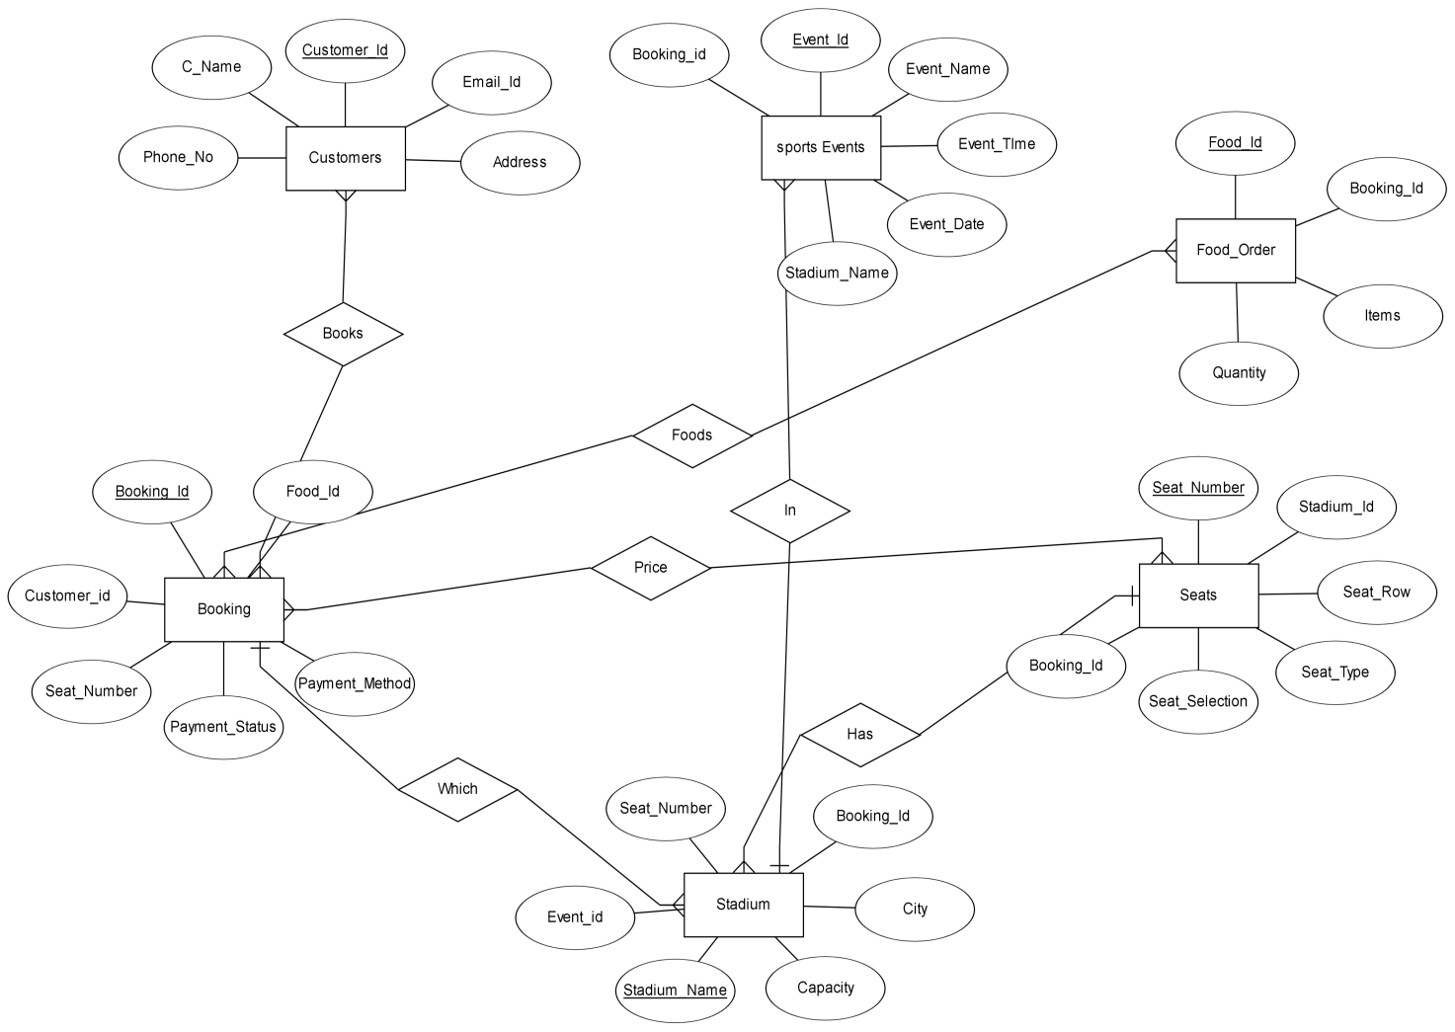

Relational Database Schema

A relational schema is a set of relational tables and associated items that are related to one another. All the base tables, views, indexes, domains, user roles, stored modules, and other items that a user creates to fulfil the data needs of a particular enterprise or set of applications belong to one schema

A relational schema is a blueprint used in database design to represent the data to be entered into the database and describe how that data is structured in tables (called relations in relational schemas). The schema describes how those tables relate to each other.

It is used to connect the primary key of one table to the foreign table of the other providing certain relations between both

**Relational Database Schema**

|  |  |  |  |  |  |
| --- | --- | --- | --- | --- | --- |
| **Customer** | Customer_id | C_Name | Email_id | Phone_No | Address |

|  |  |  |  |  |  |  |
| --- | --- | --- | --- | --- | --- | --- |
| **Sports_Event** | Event_id | Event_name | Event_Time | Event_Date | Stadium_Name | Booking_id |

|  |  |  |  |  |  |  |
| --- | --- | --- | --- | --- | --- | --- |
| **Booking** | Booking_id | Customer_id | Seat_Number | Payment_Status | Payment_Method | Food_id |

|  |  |  |  |  |  |  |
| --- | --- | --- | --- | --- | --- | --- |
| **Stadium** | Stadium_name | capacity | City | Booking_id | Seat_number | Event_id |

|  |  |  |  |  |  |  |
| --- | --- | --- | --- | --- | --- | --- |
| **Seats** | Seat_Number | Stadium_name | Seat_Row | Seat_Type | Seat_Selection | Booking_id |

|  |  |  |  |  |
| --- | --- | --- | --- | --- |
| **Foods** | Food_id | Quantity | Items | Booking_id |

Normalized table (Up to 2NF)

Table Name: Customer

Multivalued Attribute: Phone_No

|  |  |  |  |  |
| --- | --- | --- | --- | --- |
| **C_NAME** | **C_DOBooking** | **C_Gender** | **PHONE_NO** | **ADDRESS** |
| Mrinal | 31/01/2023 | M | 9151246587  7545987256 | Dhanbad |
| Abhishek | 24/01/2023 | M | 8945422121 | Jamshedpur |
| Omkar | 10/01/2023 | M | 7894213545  8465232323 | Bhubaneshwar |

**1NF : (Normalized)**

|  |  |  |  |  |
| --- | --- | --- | --- | --- |
| **C_NAME** | **C_DOBooking** | **C_Gender** | **PHONE_NO** | **ADDRESS** |
| Mrinal | 31/01/2023 | M | 9151246587 | Dhanbad |
| Mrinal | 31/01/2023 | M | 7545987256 | Dhanbad |
| Abhishek | 24/01/2023 | M | 8945422121 | Jamshedpur |
| Omkar | 10/01/2023 | M | 7894213545 | Bhubaneshwar |
| Omkar | 10/01/2023 | M | 8465232323 | Bhubaneshwar |

**R1**

|  |  |  |  |
| --- | --- | --- | --- |
| **C_NAME** | **C_DOBooking** | **ADDRESS** | **C_Gender** |
| Mrinal | 31/01/2023 | Dhanbad | M |
| Abhishek | 24/01/2023 | Jamshedpur | M |
| Omkar | 10/01/2023 | Bhubaneshwar | M |

**R2**

|  |  |  |
| --- | --- | --- |
| **C_NAME** | **­C_DOBooking** | **PHONE_NO** |
| Mrinal | 31/01/2023 | 9151246587 |
| Mrinal | 31/01/2023 | 7545987256 |
| Abhishek | 24/01/2023 | 8945422121 |
| Omkar | 10/01/2023 | 7894213545 |
| Omkar | 10/01/2023 | 8465232323 |

**2NF :**

Rules:

If it is in 1NF

There will be no partial dependency in the relationship that is proper subset of any candidate key will determine nonprime attributes.

Here

PRIME ATTRIBUTES – C_Name and C_DOBooking

NON PRIME ATTRIBUTES – C_Gender, Phone_No and Address

Customer

|  |  |  |
| --- | --- | --- |
| **C_NAME** | **DOBooking** | **C_Gender** |
| Mrinal | 31/01/2023 | M |
| Abhishek | 24/01/2023 | M |
| Omkar | 10/01/2023 | M |

Address

|  |  |
| --- | --- |
| **C_NAME** | **ADDRESS** |
| Mrinal | Dhanbad |
| Abhishek | Jamshedpur |
| Omkar | Bhubaneshwar |

Conclusion

In conclusion, a stadium seat management system in a database can greatly benefit sports venues, event organizers, and fans. By implementing such a system, venue managers can effectively manage their seating arrangements, allocate seats to attendees, and keep track of ticket sales and revenue. Fans can easily book their seats online, select their preferred seats, and receive confirmation of their booking.

In addition, a stadium seat management system in a database can help prevent double-bookings, ensure fair allocation of seats, and reduce the risk of fraudulent activities such as fake tickets. The system can also generate useful insights and analytics on ticket sales, attendance, and revenue, which can be used to make informed decisions and improve future events.

Overall, a stadium seat management system in a database is a valuable tool for sports venues and event organizers, as it enhances the overall experience for fans and streamlines the management of seating arrangements.

References

While developing this project internet was the the eternal support. Following are the websites referred by us which helped us in developing our project:

**Published paper references:**

1. V. Dinesh Kumar, K Bhargav Ram Rayal, M. Saraswathi, "Smart Gym Management System," USRET, Trends Volume 6, Issue 3, May-June-2020. [Accessed Date: 22.03.2023)
2. "Nubian Banerjee", "Comparative Analysis of Fitness Studio System with International Centres".

[Accessed Date: 26.03.2023]

1. Yagnesh G. Patel, Vishal P.Patel. "A Survey on Various Techniques of Fitness System in Web Mining", International Journal of Engineering Development and Research, 2015 Aerosol 3(4),2015,pp.696-700.

[Accessed Date: 30.03.2023]

1. Debashish Das, Laxman Sahoo, Sujoy Datta." A Survey on Fitness System". International Journal of Computer Applications, vol 160(7). February 2017, pp.6-10.

[Accessed Date: 3.04.2023]

1. "W Jason Gilmore M, Mittal 5 and Dhiman M," "Online Trading: The Future of Fitness Centers": International Journal &Management Sciences, Volume 3 Issue 61000371.

[Accessed Date: 09.04.2023]

**Website references**

1. https://www.indeed.com/career-advice/career-development/relational-database- schema

[Accessed Date: 22.03.2023]

1. <https://www.geeksforgeeks.org/relation-schema-in-dbms/>

[Accessed Date: 10.04.2023]

1. <https://www.edrawsoft.com/article/what-is-eer-diagram.html>

[Accessed Date: 17.04.2023]

1. https://www.tutorialspoint.com/check-which-fd-violates-2nf-in-the-given-relation-and- decompose-r-into2nf

[Accessed Date: 19.04.2023]